Rice Type Classification Web Application
Project Title: GrainPalette –A Deep Learning Odyssey In Rice Type Classification Through Transfer Learning
Developed by: Smart Internz Team ID - LTVIP2025TMID34308
Designed by: Geetha and Team

1. Purpose of the Project
The purpose of this project is to develop a smart application that can classify different types of rice grains using AI and provide useful agricultural suggestions based on the classification. This aids farmers, researchers, and food quality inspectors in improving rice handling, crop planning, and storage processes.
2. Use Cases
- Farmers: Determine rice type to receive water and fertilizer suggestions.
- Traders & Buyers: Verify grain type quality in marketplaces.
- Researchers: Analyze classification performance in regional varieties.
- AgriTech Startups: Integrate into larger platforms for crop advisory systems.
3. Advantages
- Fast and accurate rice type identification
- User-friendly interface for both web and desktop
- Smart suggestions for agricultural actions
- Can integrate with mobile or field devices
- Reduces manual errors in grain classification

4. About the Model
- Model Type: Convolutional Neural Network (CNN)
- Transfer Learning: Yes, used MobileNetV2 for base architecture
- Classes Predicted:
  - Arborio
  - Basmati
  - Ipsala
  - Jasmine
  - Karacadag
- Final Format: TensorFlow Lite (.tflite) model for efficiency
5. Phases of the Project
Phase 1: Problem Identification
- Manual grain sorting is inefficient.
- Needed a scalable, AI-based classification system.
Phase 2: Data Collection & Preprocessing
- Collected and labeled rice grain images.
- Augmented and resized images for uniformity.
Phase 3: Model Training
- Used MobileNetV2 with custom top layers.
- Trained using categorical crossentropy.
- Achieved high accuracy (e.g., 95%+ on validation set).
Phase 4: Model Conversion
- Converted the model to TFLite for efficient deployment.
- Optimized for mobile and web use.
Phase 5: Application Development
- Developed a Flask-based Web Application
- Users can upload or capture rice images from webcam.
- Model classifies and returns:
  - Rice Type
  - Confidence Level
  - Suggestion (e.g., water, fertilizer tips)
Phase 6: UI/UX Enhancement
- Green-black themed UI inspired by screenshots.
- Includes banners, social icons, and responsive design.
Phase 7: Deployment
- Local deployment with Flask
- Easily deployable on:
  - Render
  - PythonAnywhere
  - AWS EC2
  - Heroku (with filesystem adjustments)

6. Tools & Technologies Used
Category | Tools Used
Language | Python, HTML, CSS, JavaScript
Framework | Flask (for backend web server)
ML Framework | TensorFlow, TFLite
Model | MobileNetV2 (Transfer Learning)
Deployment | Localhost / PythonAnywhere-ready
UI Design | Custom CSS, HTML5, Responsive Layout
Image Capture | HTML5 <video> + JS Blob API

7. Project Structure
bash
CopyEdit
GrainPalette_WebApp/
│
├── app.py # Flask backend
├── templates/
│ └── index.html # Main page
│ └── result.html # Result display page
├── static/
│ ├── css/style.css # Theme styling
│ ├── js/script.js # Camera and upload JS
│ └── images/hero.jpg # Banner image
├── uploads/ # Temp image storage
├── rice_model.tflite # Deep Learning model

8. Future Enhancements
Add real-time auto-classification pipeline
Multilingual support for rural users
Mobile app version with camera integration
Cloud storage for result history and analytics

9. Architecture
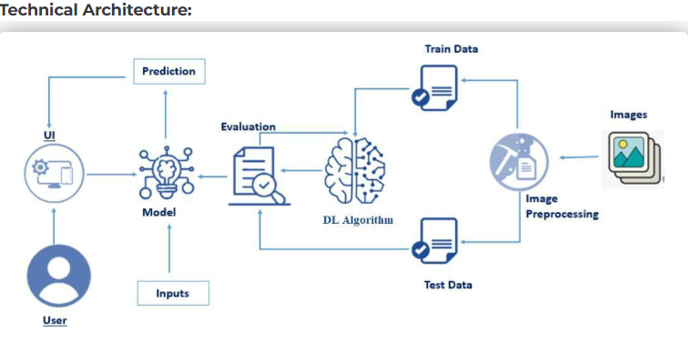
10. Quick reference links:
Python code:
https://colab.research.google.com/drive/1TTRWUdJ6eSLLrG27fI8XP2j3pCERGmtX?usp=sharing
Flask application:
https://drive.google.com/file/d/1kxfBjRjti-_CctZrqdKSQgpp8DSIdSQi/view?usp=sharing
Rice data set:
https://drive.google.com/file/d/1rxWHDElhxLF4HSZ44FFYojyv57zx9A8D/view?usp=sharing
Demo video:
https://drive.google.com/file/d/1I30Pxa65AuVoZ7yeks6HSJsaA9dLvWXi/view?usp=sharing
Git Hub:
https://github.com/Bvk277353/Smart-internz-project-grain-palette--rice-type-classifier-.git

